# Lab: Design Patterns

Problems for in-class lab for the [Python OOP Course @SoftUni](https://softuni.bg/courses/python-oop).

## Abstract Factory

We are going to create an **AbstractFactory** class that will have methods for creating **chairs**, **sofas** and **tables**

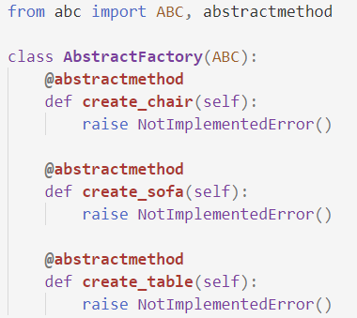

Then we are going to create the **Chair**, **Sofa** and **Table** classes

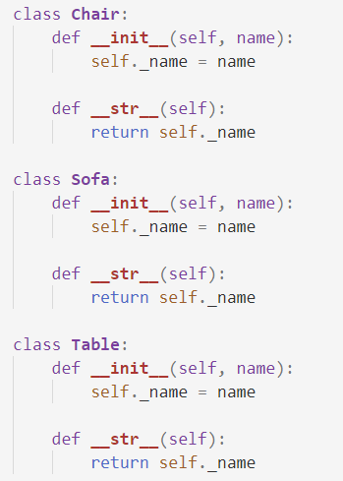

Finally, we are going to create **three** different factories that **will inherit** from the **AbstractFactiory** class: **VictorianFactory**, **ModernFactory**, **FuturisticFactory**

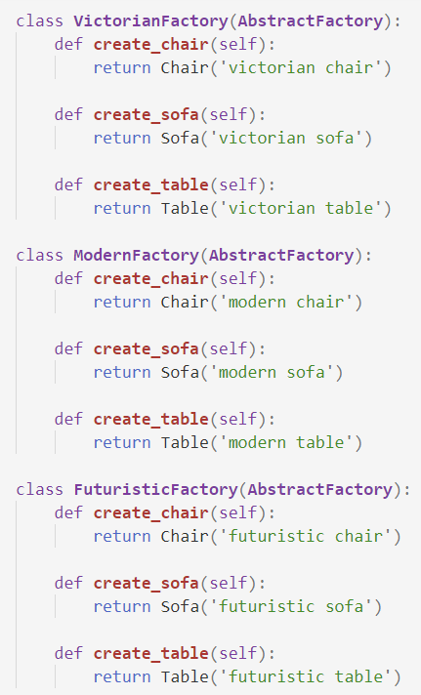

## Composite

We are going to create a class called **Component** which will have **move** and **delete** methods

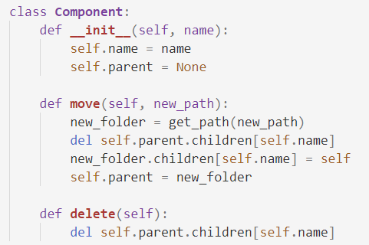

Create two more classes: **Folder** and **File** which **inherit** from **Component**. The **Folder** class should have an **add_child** method

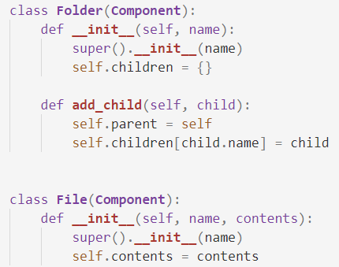

Create a **root folder** and implement the method **get_path**

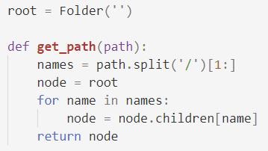

## Command

Create class **Window** and class **Document**. The Window class will have an **exit** method, the Document class will have a **save** method

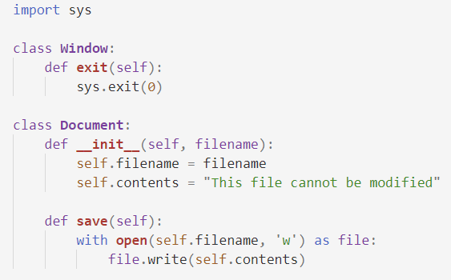

Next, we will create the classes **ToolbarDocument**, **MenuItem** and **KeyboardShortcut**. The **ToolbarDocument** and the **MenuItem** will have a method **click**. The **KeyboardShortcut** should have a method called **keypress**.

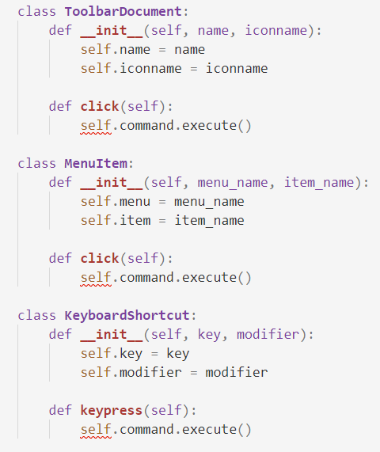

Finally, we will create two **command classes** **SaveCommand** and **ExitCommand** which will have the **execute** methods implemented in them

